Laboratory work #2
Part1 Normalization

Task 1. Normal Form Violations

The Booking_receipt table violates 1NF because the seat_numbers column contains multiple values in one cell (for example: 12A, 12B). Each attribute must contain only atomic values. The table can also violate 2NF when a composite key is used because some attributes depend only on part of the key. It violates 3NF because of transitive dependencies such as flight_number determining airline_name.

Task 2. Step-by-step normalization

Step 1 — First Normal Form (1NF)
1NF:
Booking_receipt_1NF(booking_id, passenger_id, passenger_full_name, passport_number, flight_number, seat_number, ticket_price)
Primary Key: (booking_id, passenger_id)
Step 2: Second Normal Form (2NF)
2NF:
BOOKING(booking_id PK, flight_number FK, ticket_price)
PASSENGER(passenger_id PK, passenger_full_name, passport_number)
BOOKING_PASSENGER(booking_id PK/FK, passenger_id PK/FK, seat_number)
Step 3 — Third Normal Form (3NF)
3NF:
AIRLINE(airline_id PK, airline_name)
AIRPORT(airport_id PK, airport_name, city)
FLIGHT(flight_number PK, departure_airport_id FK, arrival_airport_id FK, airline_id FK)
BOOKING(booking_id PK, flight_number FK, ticket_price)
PASSENGER(passenger_id PK, passenger_full_name, passport_number)
BOOKING_PASSENGER(booking_id PK/FK, passenger_id PK/FK, seat_number)
Task 3: Functional Dependencies
booking_id -> flight_number, ticket_price
passenger_id -> passenger_full_name, passport_number
flight_number -> airline_id, departure_airport_id, arrival_airport_id
airline_id -> airline_name
airport_id -> airport_name, city
Task 4: Checking the Flights Table
The primary key of the Flights table is flight_id.The Flights table is in 3NF because all non-key attributes depend only on the primary key flight_id.

Airport and airline information are stored in separate tables using foreign keys. Therefore, there are no transitive dependencies inside the Flights table.
Task 5.
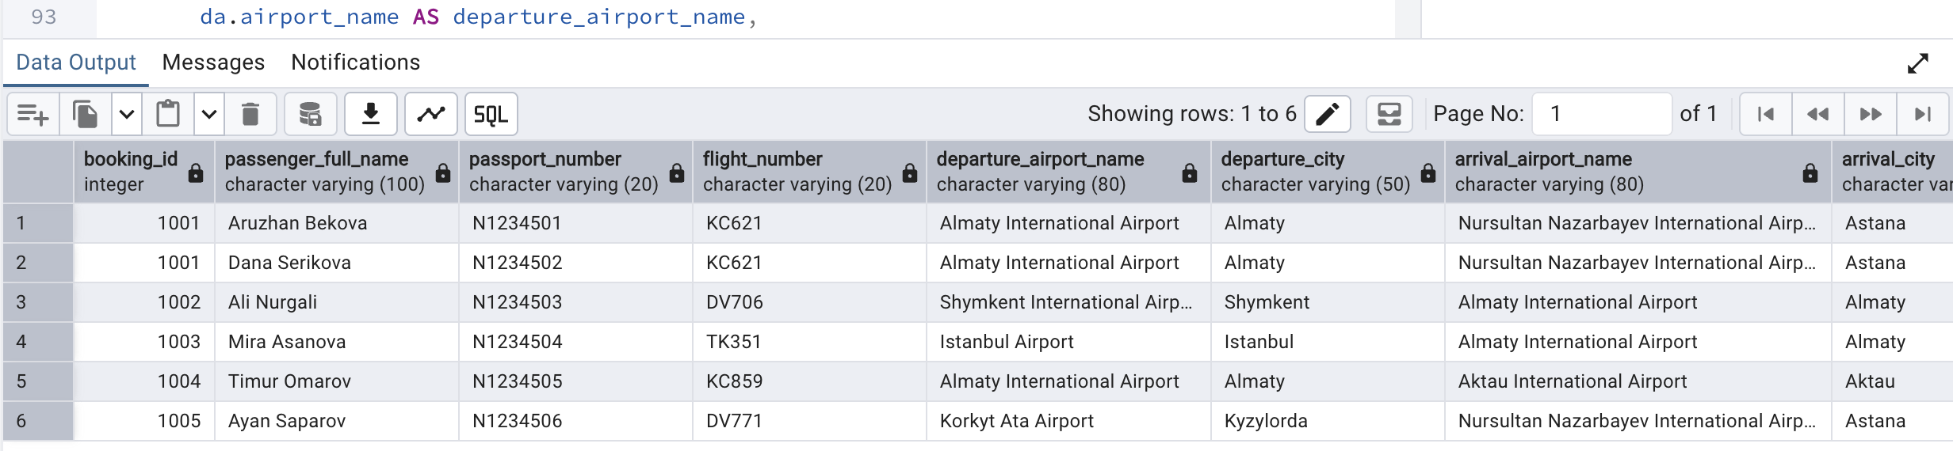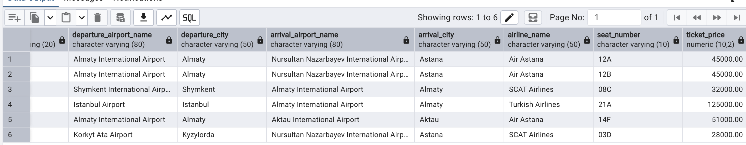
CREATE TABLE receipt_airline (
airline_id INT PRIMARY KEY,
airline_name VARCHAR(50) NOT NULL UNIQUE
);
CREATE TABLE receipt_airport (
airport_id INT PRIMARY KEY,
airport_name VARCHAR(80) NOT NULL UNIQUE,
city VARCHAR(50) NOT NULL
);
CREATE TABLE receipt_flight (
flight_number VARCHAR(20) PRIMARY KEY,
departure_airport_id INT NOT NULL REFERENCES receipt_airport(airport_id),
arrival_airport_id INT NOT NULL REFERENCES receipt_airport(airport_id),
airline_id INT NOT NULL REFERENCES receipt_airline(airline_id),
CHECK (departure_airport_id <> arrival_airport_id)
);
CREATE TABLE receipt_passenger (
passenger_id INT PRIMARY KEY,
passenger_full_name VARCHAR(100) NOT NULL,
passport_number VARCHAR(20) NOT NULL UNIQUE
);
CREATE TABLE receipt_booking (
booking_id INT PRIMARY KEY,
flight_number VARCHAR(20) NOT NULL REFERENCES receipt_flight(flight_number),
ticket_price NUMERIC(10,2) NOT NULL CHECK (ticket_price >= 0)
);
CREATE TABLE receipt_booking_passenger (
booking_id INT NOT NULL REFERENCES receipt_booking(booking_id),
passenger_id INT NOT NULL REFERENCES receipt_passenger(passenger_id),
seat_number VARCHAR(10) NOT NULL,
PRIMARY KEY (booking_id, passenger_id),
UNIQUE (booking_id, seat_number)
);
INSERT INTO receipt_airline (airline_id, airline_name) VALUES
(1, 'Air Astana'),
(2, 'SCAT Airlines'),
(3, 'Turkish Airlines');
INSERT INTO receipt_airport (airport_id, airport_name, city) VALUES
(1, 'Almaty International Airport', 'Almaty'),
(2, 'Nursultan Nazarbayev International Airport', 'Astana'),
(3, 'Shymkent International Airport', 'Shymkent'),
(4, 'Istanbul Airport', 'Istanbul'),
(5, 'Aktau International Airport', 'Aktau'),
(6, 'Korkyt Ata Airport', 'Kyzylorda');
INSERT INTO receipt_flight
(flight_number, departure_airport_id, arrival_airport_id, airline_id) VALUES
('KC621', 1, 2, 1),
('DV706', 3, 1, 2),
('TK351', 4, 1, 3),
('KC859', 1, 5, 1),
('DV771', 6, 2, 2);
INSERT INTO receipt_passenger
(passenger_id, passenger_full_name, passport_number) VALUES
(1, 'Aruzhan Bekova', 'N1234501'),
(2, 'Dana Serikova', 'N1234502'),
(3, 'Ali Nurgali', 'N1234503'),
(4, 'Mira Asanova', 'N1234504'),
(5, 'Timur Omarov', 'N1234505'),
(6, 'Ayan Saparov', 'N1234506');
INSERT INTO receipt_booking (booking_id, flight_number, ticket_price) VALUES
(1001, 'KC621', 45000.00),
(1002, 'DV706', 32000.00),
(1003, 'TK351', 125000.00),
(1004, 'KC859', 51000.00),
(1005, 'DV771', 28000.00);
-- Booking 1001 contains two passengers, proving that the former
-- comma-separated value ('12A, 12B') is represented by atomic rows.
INSERT INTO receipt_booking_passenger
(booking_id, passenger_id, seat_number) VALUES
(1001, 1, '12A'),
(1001, 2, '12B'),
(1002, 3, '08C'),
(1003, 4, '21A'),
(1004, 5, '14F'),
(1005, 6, '03D');
-- Reconstruct a receipt-style result from the 3NF tables.
SELECT b.booking_id,
p.passenger_full_name,
p.passport_number,
f.flight_number,
da.airport_name AS departure_airport_name,
da.city AS departure_city,
aa.airport_name AS arrival_airport_name,
aa.city AS arrival_city,
al.airline_name,
bp.seat_number,
b.ticket_price
FROM receipt_booking AS b
JOIN receipt_flight AS f ON f.flight_number = b.flight_number
JOIN receipt_airline AS al ON al.airline_id = f.airline_id
JOIN receipt_airport AS da ON da.airport_id = f.departure_airport_id
JOIN receipt_airport AS aa ON aa.airport_id = f.arrival_airport_id
JOIN receipt_booking_passenger AS bp ON bp.booking_id = b.booking_id
JOIN receipt_passenger AS p ON p.passenger_id = bp.passenger_id
ORDER BY b.booking_id, bp.seat_number;
PART 2 — DDL
SQL — Create all required tables with PK and NOT NULL constraints
CREATE TABLE airline_info (
airline_id INT PRIMARY KEY,
airline_code VARCHAR(30) NOT NULL,
airline_name VARCHAR(50) NOT NULL,
airline_country VARCHAR(50) NOT NULL,
created_at TIMESTAMP NOT NULL,
updated_at TIMESTAMP NOT NULL,
info VARCHAR(50) NOT NULL
);
CREATE TABLE airport (
airport_id INT PRIMARY KEY,
airport_name VARCHAR(50) NOT NULL,
country VARCHAR(50) NOT NULL,
state VARCHAR(50) NOT NULL,
city VARCHAR(50) NOT NULL,
created_at TIMESTAMP NOT NULL,
updated_at TIMESTAMP NOT NULL
);
CREATE TABLE passengers (
passenger_id INT PRIMARY KEY,
first_name VARCHAR(50) NOT NULL,
last_name VARCHAR(50) NOT NULL,
date_of_birth DATE NOT NULL,
gender VARCHAR(50) NOT NULL,
country_of_citizenship VARCHAR(50) NOT NULL,
country_of_residence VARCHAR(50) NOT NULL,
passport_number VARCHAR(20) NOT NULL,
created_at TIMESTAMP NOT NULL,
updated_at TIMESTAMP NOT NULL
);
CREATE TABLE flights (
flight_id INT PRIMARY KEY,
sch_departure_time TIMESTAMP NOT NULL,
sch_arrival_time TIMESTAMP NOT NULL,
departing_airport_id INT NOT NULL,
arriving_airport_id INT NOT NULL,
departing_gate VARCHAR(50) NOT NULL,
arriving_gate VARCHAR(50) NOT NULL,
airline_id INT NOT NULL,
act_departure_time TIMESTAMP NOT NULL,
act_arrival_time TIMESTAMP NOT NULL,
created_at TIMESTAMP NOT NULL,
updated_at TIMESTAMP NOT NULL
);
CREATE TABLE booking (
booking_id INT PRIMARY KEY,
flight_id INT NOT NULL,
passenger_id INT NOT NULL,
booking_platform VARCHAR(50) NOT NULL,
created_at TIMESTAMP NOT NULL,
updated_at TIMESTAMP NOT NULL,
status VARCHAR(50) NOT NULL,
price DECIMAL(7,2) NOT NULL
);
CREATE TABLE baggage_check (
baggage_check_id INT PRIMARY KEY,
check_result VARCHAR(50) NOT NULL,
created_at TIMESTAMP NOT NULL,
updated_at TIMESTAMP NOT NULL,
booking_id INT NOT NULL,
passenger_id INT NOT NULL
);
CREATE TABLE baggage (
baggage_id INT PRIMARY KEY,
weight_in_kg DECIMAL(4,2) NOT NULL,
created_at TIMESTAMP NOT NULL,
updated_at TIMESTAMP NOT NULL,
booking_id INT NOT NULL
);
CREATE TABLE boarding_pass (
boarding_pass_id INT PRIMARY KEY,
booking_id INT NOT NULL,
seat VARCHAR(50) NOT NULL,
boarding_time TIMESTAMP NOT NULL,
created_at TIMESTAMP NOT NULL,
updated_at TIMESTAMP NOT NULL
);
CREATE TABLE booking_flight (
booking_flight_id INT PRIMARY KEY,
booking_id INT NOT NULL,
flight_id INT NOT NULL,
created_at TIMESTAMP NOT NULL,
updated_at TIMESTAMP NOT NULL
);
CREATE TABLE security_check (
security_check_id INT PRIMARY KEY,
check_result VARCHAR(20) NOT NULL,
created_at TIMESTAMP NOT NULL,
updated_at TIMESTAMP NOT NULL,
passenger_id INT NOT NULL
);
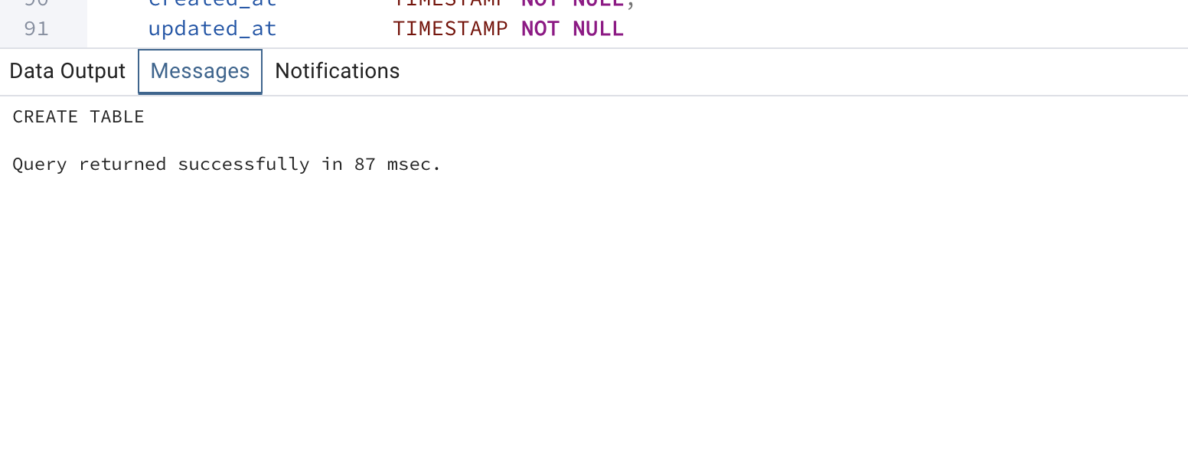SQL — Required ALTER TABLE operations
ALTER TABLE airline_info RENAME TO airline;
ALTER TABLE booking RENAME COLUMN price TO ticket_price;
ALTER TABLE flights ALTER COLUMN departing_gate TYPE TEXT;
ALTER TABLE airline DROP COLUMN info;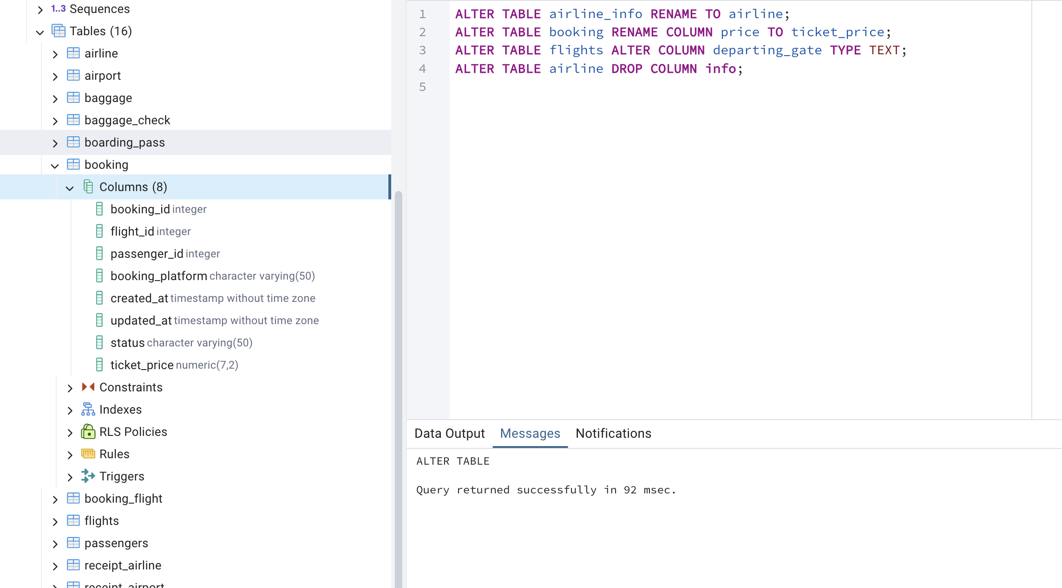
SQL — Foreign-key relationships
ALTER TABLE security_check
ADD CONSTRAINT fk_security_passenger
FOREIGN KEY (passenger_id) REFERENCES passengers(passenger_id);
ALTER TABLE booking
ADD CONSTRAINT fk_booking_passenger
FOREIGN KEY (passenger_id) REFERENCES passengers(passenger_id);
ALTER TABLE baggage_check
ADD CONSTRAINT fk_baggage_check_passenger
FOREIGN KEY (passenger_id) REFERENCES passengers(passenger_id),
ADD CONSTRAINT fk_baggage_check_booking
FOREIGN KEY (booking_id) REFERENCES booking(booking_id);
ALTER TABLE baggage
ADD CONSTRAINT fk_baggage_booking
FOREIGN KEY (booking_id) REFERENCES booking(booking_id);
ALTER TABLE boarding_pass
ADD CONSTRAINT fk_boarding_pass_booking
FOREIGN KEY (booking_id) REFERENCES booking(booking_id);
ALTER TABLE booking_flight
ADD CONSTRAINT fk_booking_flight_booking
FOREIGN KEY (booking_id) REFERENCES booking(booking_id),
ADD CONSTRAINT fk_booking_flight_flight
FOREIGN KEY (flight_id) REFERENCES flights(flight_id);
ALTER TABLE flights
ADD CONSTRAINT fk_flights_departing_airport
FOREIGN KEY (departing_airport_id) REFERENCES airport(airport_id),
ADD CONSTRAINT fk_flights_arriving_airport
FOREIGN KEY (arriving_airport_id) REFERENCES airport(airport_id),
ADD CONSTRAINT fk_flights_airline
FOREIGN KEY (airline_id) REFERENCES airline(airline_id);
-- The task explicitly requests Flights -> Booking_flight. The following FK
-- is also implied by the flight_id column in Booking and is recommended.
ALTER TABLE booking
ADD CONSTRAINT fk_booking_flight_direct
FOREIGN KEY (flight_id) REFERENCES flights(flight_id);
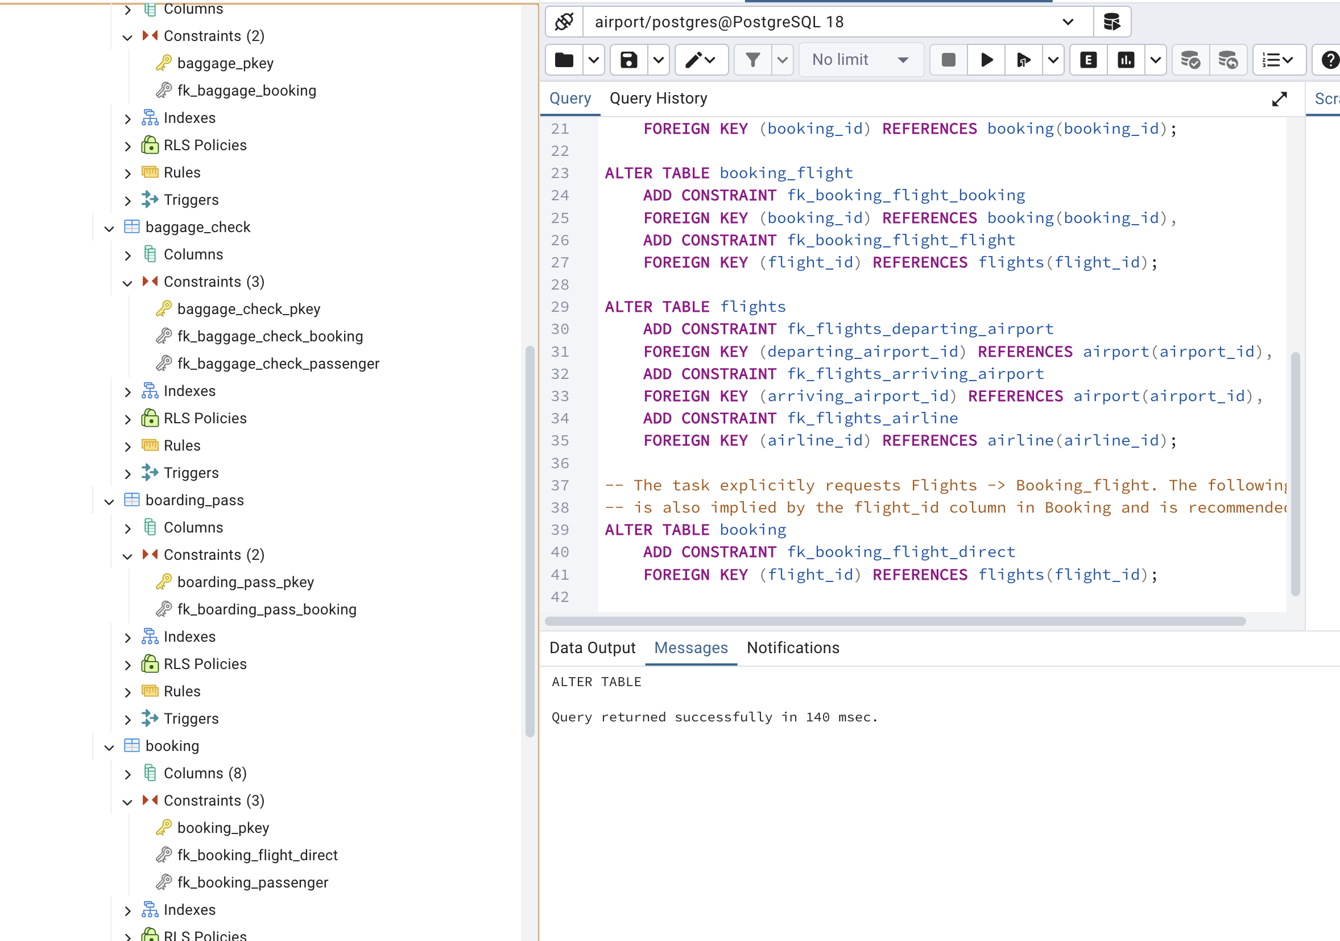

SQL — Verification queries
SELECT table_name
FROM information_schema.tables
WHERE table_schema = 'public'
ORDER BY table_name;
SELECT tc.table_name, tc.constraint_name, tc.constraint_type
FROM information_schema.table_constraints AS tc
WHERE tc.table_schema = 'public'
ORDER BY tc.table_name, tc.constraint_type;
SELECT column_name, data_type, is_nullable
FROM information_schema.columns
WHERE table_schema = 'public' AND table_name = 'flights'
ORDER BY ordinal_position;
